(CL1002) Programming Fundamentals Lab

Lab 8 Task:

▪ Before doing the task, I recommend you all to go through the lab manual. It will make it easy for you all to understand this.

▪ Copied task will be awarded **zero** marks.

▪ Upload only a MS word and PDF file including all tasks source code and its output (screen shot).

▪ You have to copy the source code in your word file. Don't take the screen shot of source code.

▪ Use the following format for naming the word file Rollno_name (21P-1234_zain). ▪ Comments your Code Properly

1. Write a Program to Calculate Permutation(nPr) for given values of n and r The **nPr** (permutation) formula is:

**Sample Output:**





2. Write a program that accepts an integer and displays its factors. For example, if the user enters 12, the program should display 2, 3, 4 and 6.

3. Find the sum of the first 10 numbers that are divisible by 3 and 9. **Sample Output**

*495*

4. In Fibonacci series, every new term is generated by adding the previous two terms as shown below. Write a program that displays Fibonacci series between 0 to user input range.

0,1,1,2,3,5,8,13, … … …

**Sample Output:**

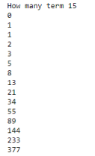

5. Write a program that performs a survey tally on beverages. The program should prompt for the next person until a sentinel value of –1 is entered to terminate the program. Each person participating in the survey should choose their favorite beverage from the following list:

| 1. Coffee | 2. Tea | 3. Coke | 4. Orange Juice |
| --- | --- | --- | --- |

**Sample Output:**

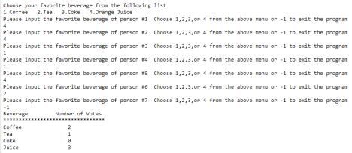

**Additional Task (Not Graded)**

6. Write a program that takes two numbers from the user and displays all prime numbers between them. For example, if the user enters 5 and 15, your program should display 5, 7, 11, 13.